Must Love Dogs Training and Mentoring Programme


August 10

Trainer and Mentor: Kelly Wardle


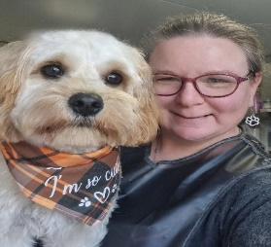
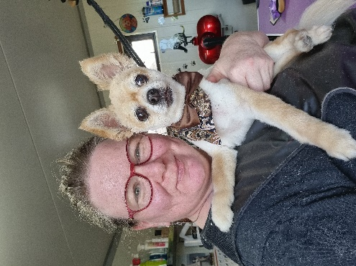
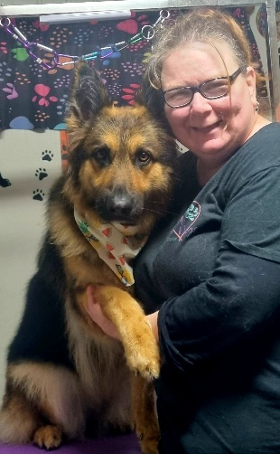
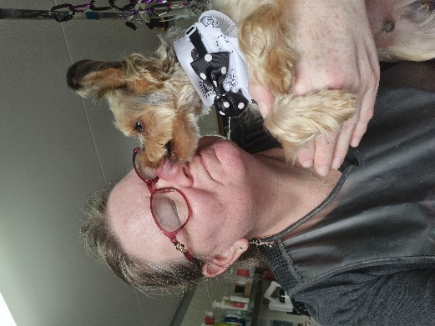
Course Outline
First Steps for Passionate Dog Groomers

I will show you how to turn your love of dogs into a career – Just Like I did!

Topic Workshops:
- Caring and Calm Environments for Dogs and Groomers
- Essential Equipment and Tools for Grooming
- Dog Handling and Safety Procedures
- Basic Brushing and Coat Types
- Washing and Drying Basics
- Clippers: Blades and Comb Sizes
- Nail Trimming and Grinding Techniques
- Trimming Paw Pads and Sanitary Areas
- Customer Service

Delivery
- Small Groups 4 – 6
- 16 Hours - Topic workshops: theory and practical
- 2 x 8 hours days (Friday/Saturday) or 4 x 4 hours (Evenings)
- Monthly follow up mentoring visits 6 months

Cost (includes lunch and refeshments)
$1500 + GST (Payment options available)
(Includes a starter kit – scissors, comb, apron, various samples, Training Handbook)
Deposit required to secure place (refundable up to week prior to course start)

Apply on line at www.justlovedogs.co.nz>Training and Development

